
AI-Powered Customer Service Chatbot


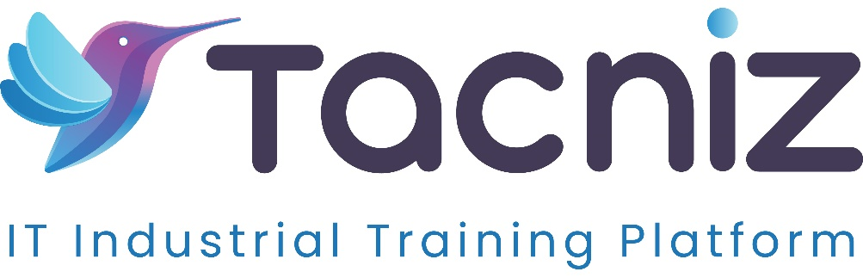

Problem Statement
Many businesses struggle to offer 24/7 customer support, leading to long wait times and inconsistent service experiences. Customers expect fast, accurate responses to their inquiries, but maintaining a round-the-clock customer support team can be costly and resource-intensive. An AI-powered chatbot can address these issues by providing real-time responses to common questions, reducing wait times, and improving the overall service experience. With natural language processing (NLP), the chatbot can understand and respond to a variety of customer queries, providing efficient support even outside business hours.

Project Type
- Type: AI-Powered Chatbot Application
Category: Customer Service Automation, Artificial Intelligence, NLP

Industry Area
- Industry: Customer Service, E-commerce, Retail, Technology
- Relevant Sectors: Customer Support, AI and Automation, E-commerce Customer Engagement, Financial Services

Software Expertise Required
Developing an AI-powered customer service chatbot requires expertise in several technical areas:
- Natural Language Processing (NLP): Proficiency in NLP tools and libraries like spaCy, NLTK, or advanced models like GPT or BERT for understanding and processing customer queries.
- Machine Learning: Skills in training and deploying machine learning models, particularly those used for NLP, to enable the chatbot to learn from interactions and improve over time.
- Backend Development: Experience in backend frameworks such as Django, Flask, or Node.js for managing chatbot responses, user sessions, and integrations with existing customer support systems.
- Database Management: Expertise in databases like MySQL or MongoDB to store conversation logs, customer data, and chatbot response history, allowing for data-driven improvements.
- API Integration with Customer Support Systems: Ability to integrate the chatbot with platforms like Zendesk, Salesforce, or Freshdesk to escalate complex queries to human agents when necessary.
- Real-Time Learning and Feedback Mechanisms: Knowledge of machine learning techniques that allow the chatbot to learn from customer interactions, improving its accuracy and response quality over time.
- Data Security and Compliance: Understanding of data privacy standards to secure customer data and ensure compliance with regulations such as GDPR or CCPA.

Key Features
- AI-Driven Natural Language Processing (NLP): The chatbot leverages advanced NLP models to understand and interpret customer queries, ensuring that responses are relevant and accurate.
- Automated Responses for Common Questions: Pre-trained responses handle frequently asked questions, reducing the need for human intervention on repetitive tasks, such as answering questions about operating hours, policies, or product information.
- Integration with Customer Service Platforms for Escalation: For queries that require human assistance, the chatbot can automatically escalate to a customer service platform like Zendesk or Salesforce, creating a seamless handoff for complex issues.
- Real-Time Learning from Customer Interactions: The chatbot continuously learns from interactions, improving its accuracy and expanding its knowledge base, which results in better responses over time.
- Multi-Platform Availability: The chatbot can be deployed on websites, mobile apps, and social media platforms, providing consistent support across multiple channels.

Use Cases
- For E-commerce Stores: The chatbot can assist customers with order tracking, product information, and return policies, providing 24/7 support that enhances the shopping experience.
- For Financial Services: It can respond to inquiries about account balances, transaction statuses, and provide answers to common questions about banking services, improving support without needing live agents.
- For Healthcare Providers: The chatbot can answer questions about clinic hours, appointment booking, and COVID-19 guidelines, helping healthcare providers manage high volumes of inquiries.
- For Tech Companies: It can handle support questions about software usage, troubleshooting, and user account issues, ensuring users get timely help with minimal wait times.

Expected Outcomes
The AI-powered chatbot will reduce customer wait times, ensure 24/7 support availability, and improve overall customer satisfaction. By handling common inquiries automatically, the chatbot frees up human agents to focus on complex issues, creating a more efficient and effective customer service experience. Over time, real-time learning enhances the chatbot’s accuracy, further improving the quality of responses and customer satisfaction.

Benefits
- Reduced Customer Wait Times: Customers receive instant responses to common inquiries, eliminating the need to wait for a human agent.
- Improved Support Availability: The chatbot provides 24/7 support, ensuring that customers receive assistance at any time, enhancing customer satisfaction.
- Increased Efficiency for Customer Support Teams: Automated responses for routine questions reduce the workload on human agents, allowing them to focus on high-priority tasks.
- Enhanced Customer Experience: Customers experience faster resolution of their questions and a consistent support experience across all communication channels.
- Cost Savings: By reducing the need for additional staffing for customer support, businesses can save on operational costs while still providing excellent service.
- Scalability: The AI-powered chatbot can easily handle increased inquiry volumes, making it a scalable solution that grows with the business.

Project Duration
Estimated Duration: 4-5 months for development, testing, and deployment, with additional time for training and fine-tuning the NLP model.

